**Installing MiniAnaconda**

1. Download the installer:

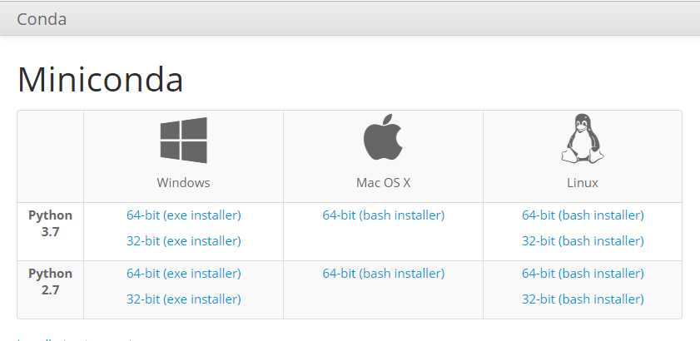

* + [Miniconda installer for Windows](https://conda.io/miniconda.html). or
  + [Anaconda installer for Windows](https://www.anaconda.com/download/).

1. After finish downloaded, Double-click the .exe file.

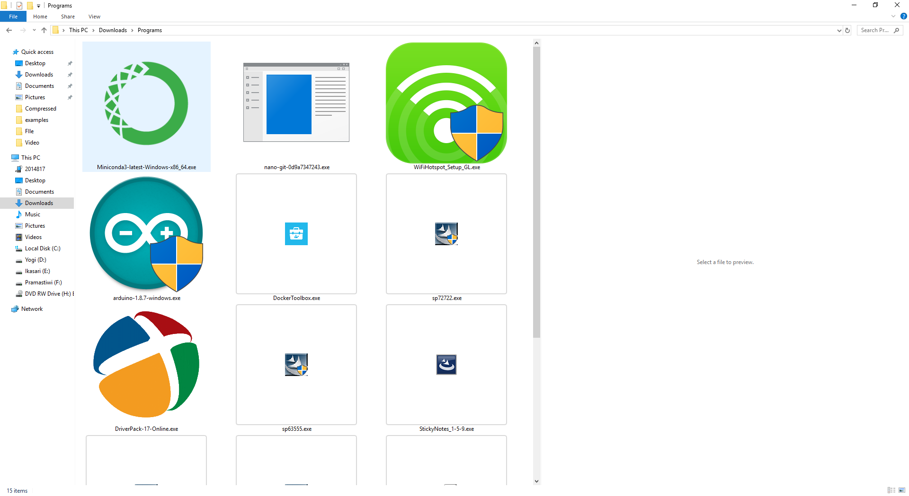

1. Follow the instructions on the screen.

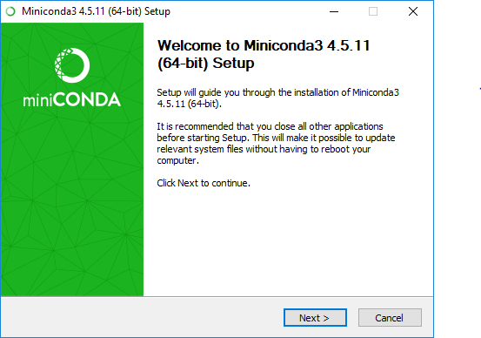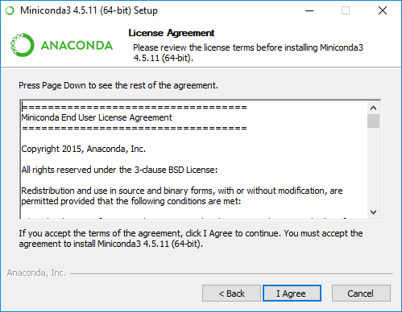

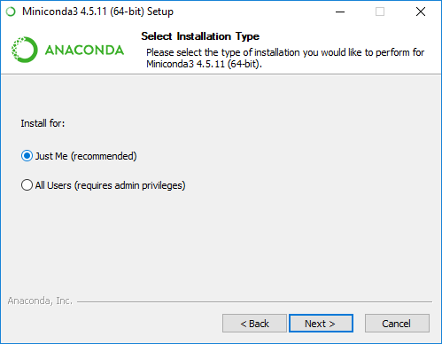 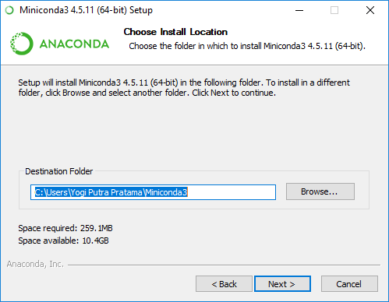

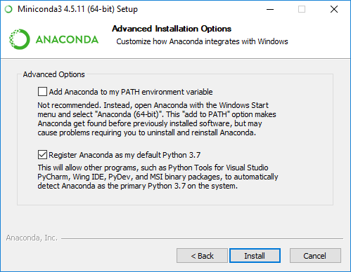 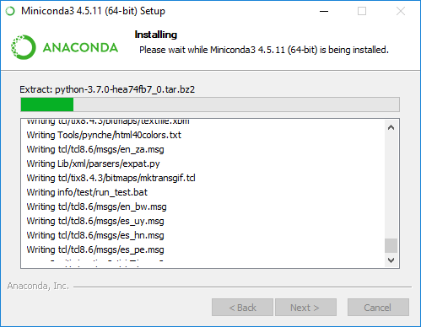

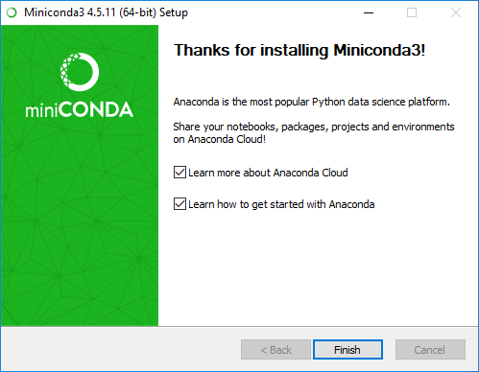

If you are unsure about any setting, accept the defaults. You can change them later.

When installation is finished, from **the Start menu**, open **the Anaconda Prompt**.

1. **To test your installation**, in your Terminal window or Anaconda Prompt, run the command **conda list**.

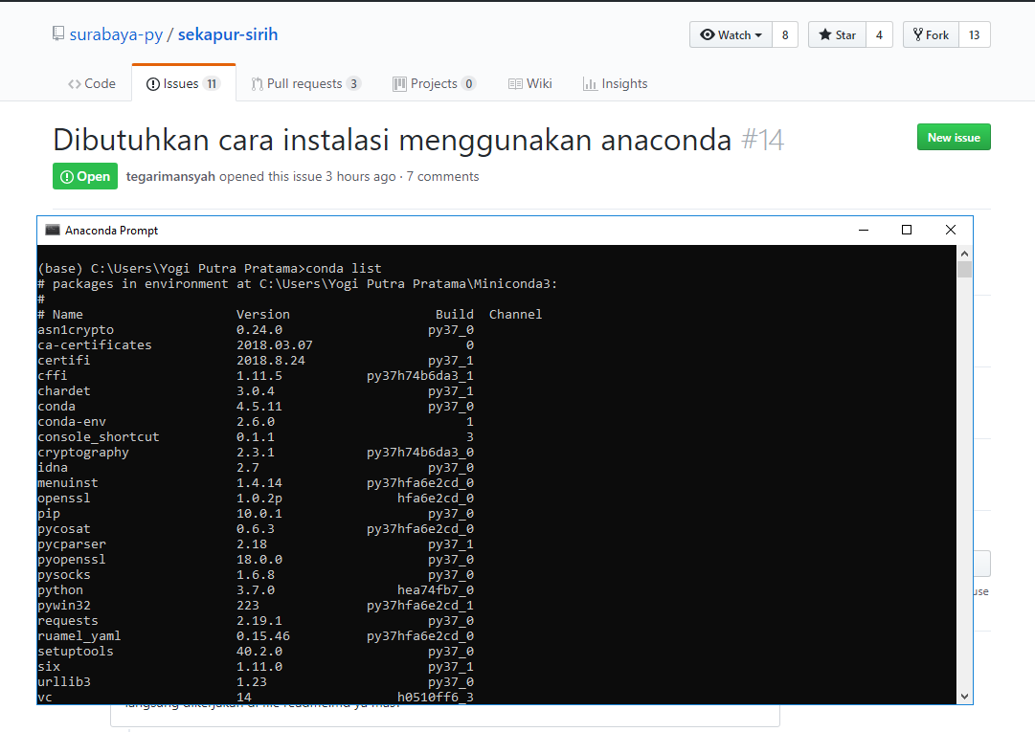

For a successful installation, a list of installed packages appears. Great Job !

**Updating conda**

1. Open your Anaconda Prompt from the start menu.
2. Navigate to the anaconda directory.
3. Run **conda update conda**.

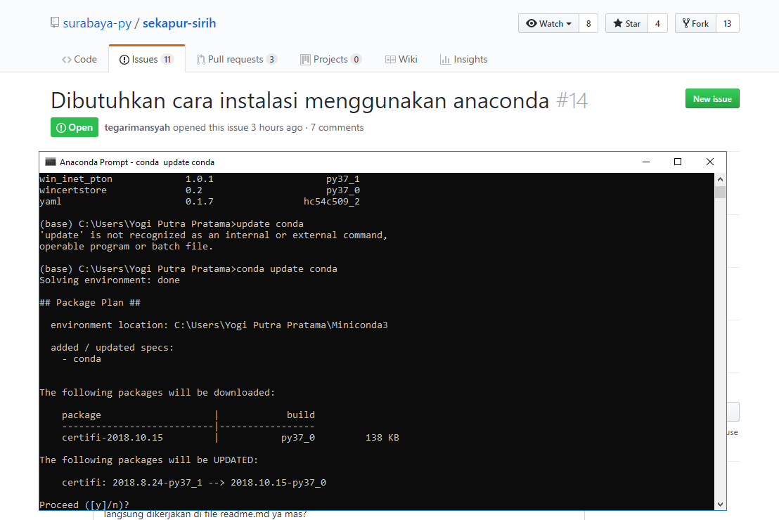

**Uninstalling conda**

1. In the Windows Control Panel, click Add or Remove Program.
2. Select Python X.X (Miniconda), where X.X is your version of Python.
3. Click Remove Program.